Why Algebra?
What Algebra?

Working Group Presentation

Gard Brekke, Mollie McGregor
Jack Abramsky, Michael Bulmer, Hugh Burkhardt, Anne Crawford,
Claude.Gaulin, Per-Eskil Persson, Alla Routinsky

ICMI Algebra Study Conference
University of Melbourne
December 2001

Our focus: the minimum
Algebra for All (most)
in
Compulsory Education

We will NOT discuss:

• Teaching for ‘connections’ ......
rich activities, not just “EEE”

• Professional development
.... related to the above

• Teacher knowledge, for the minimum
particularly, modelling the real world

• Impact of technology on algebra

• System change issues

Why Algebra for All?

• societies’ increasing demands for maths

• technology demands symbolism

• equal access to career opportunities

• key to higher level mathematics

• natural language for problem solving

• providing intellectual challenge

• supports power of reasoning and
critical analysis

• “We are abstracting animals”

Phases of Problem Solving

Problem

Model

Meaning

Solution
formulate
mathematize
transform
manipulate
The relative importance of each phase
varies with the problem (type)
interpret

evaluate
A Designing Structure
Modelling +
‘pure’
problem solving
Mathematical
toolkit
World
knowledge
Abstraction
Generalization
Symbolization
Career
capabilities ....................
Examples

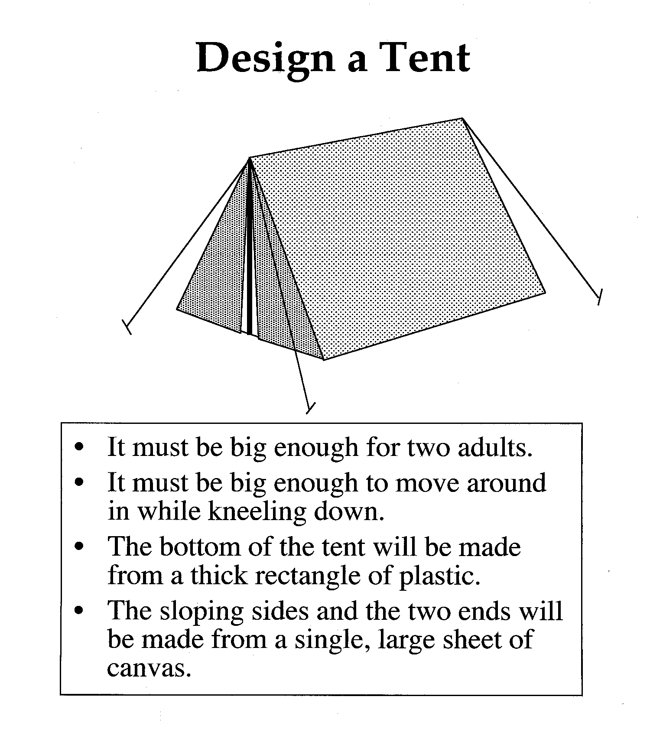

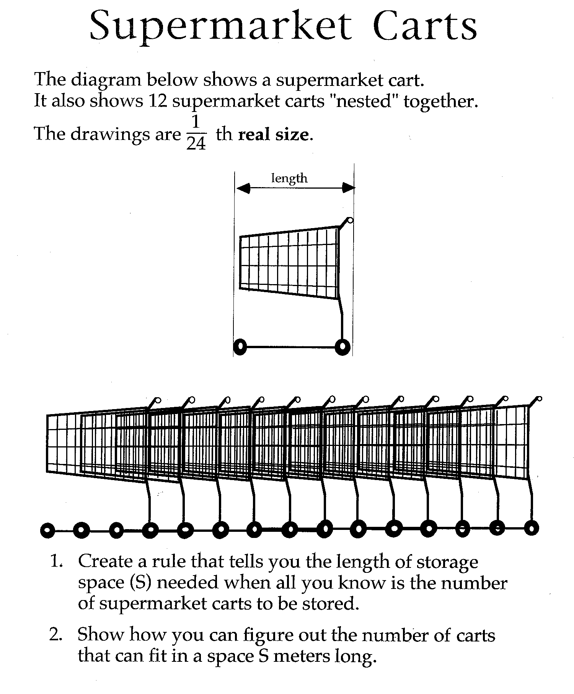

Border Tiles
When tiling, people sometimes use special tiles that have borders on them.
The six possible tiles are shown below.
Tiles are placed together to make rectangles with dark borders around the perimeter. eg
Write a general rule for the number of each type of tile in a class of rectangles (eg 2 x n).
Justify or explain why your rules work for all the rectangles in the class.
Do this for as many classes of rectangles as you can.
Fibonacci Sequences

1, 1, 2, 3, 5, 8, 13, 21, 34, 55, 89, 144, 233, ...

Fibonacci puzzles

Fill in the missing number in these Fibonacci sequences:

1 | 3 | 4 | 7 | 11

3 | 1 |  |  |  | 14

7 |  |  | 15 |  | 41

The next three are more difficult!

3 |  |  |  |  | 49

5 |  |  |  |  | 50

8 |  |  |  |  | 9

Try to find a good method for solving puzzles like these difficult ones.
Use algebra if it helps.

Explain your method, and make up some examples to show how your method works.
Aspects of
Algebraic Thinking

• abstraction and generalization
• a sense of variables and symbols
• symbolic ⇔ other representations

• strategies for formulating
symbolic models, using
your mathematical toolkit

• tactical solution planning
including anticipation, route ....
• tactics for manipulating, eg
doing and undoing
balancing .....
• avoiding unnecessary calculation

• interpreting and evaluating solutions
• explaining and justifying
Examples

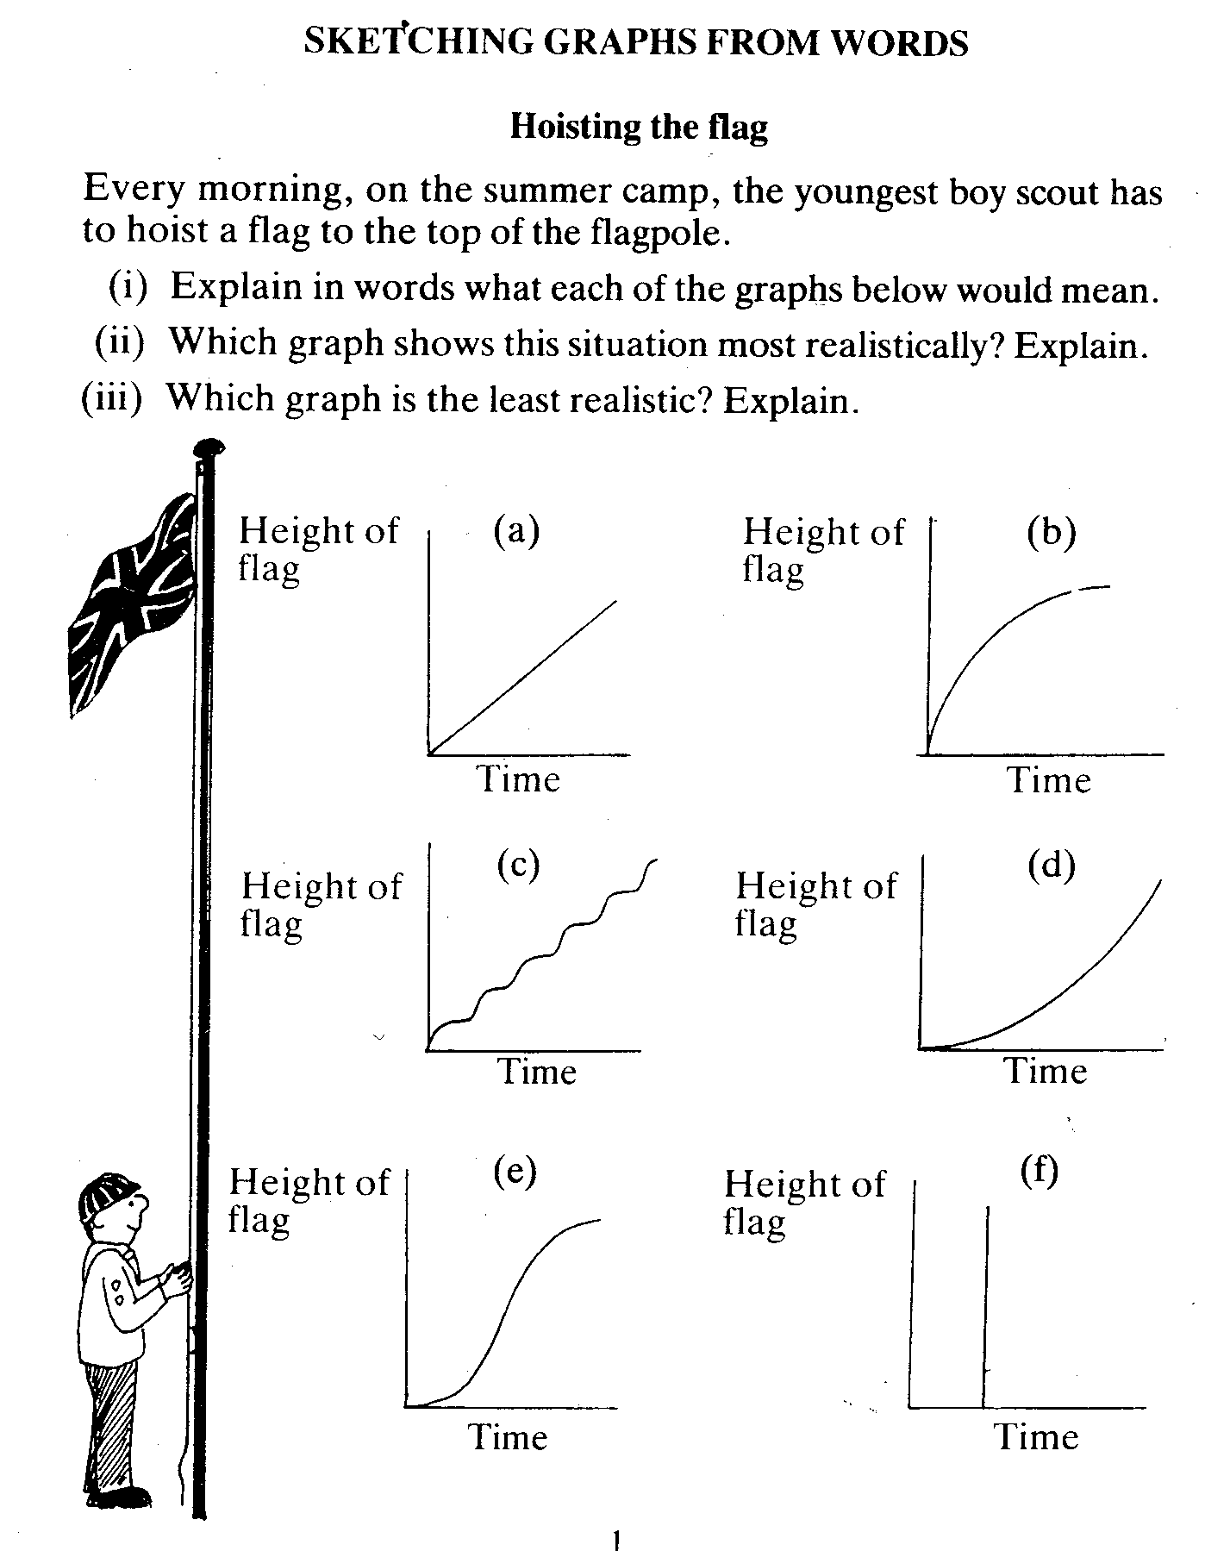

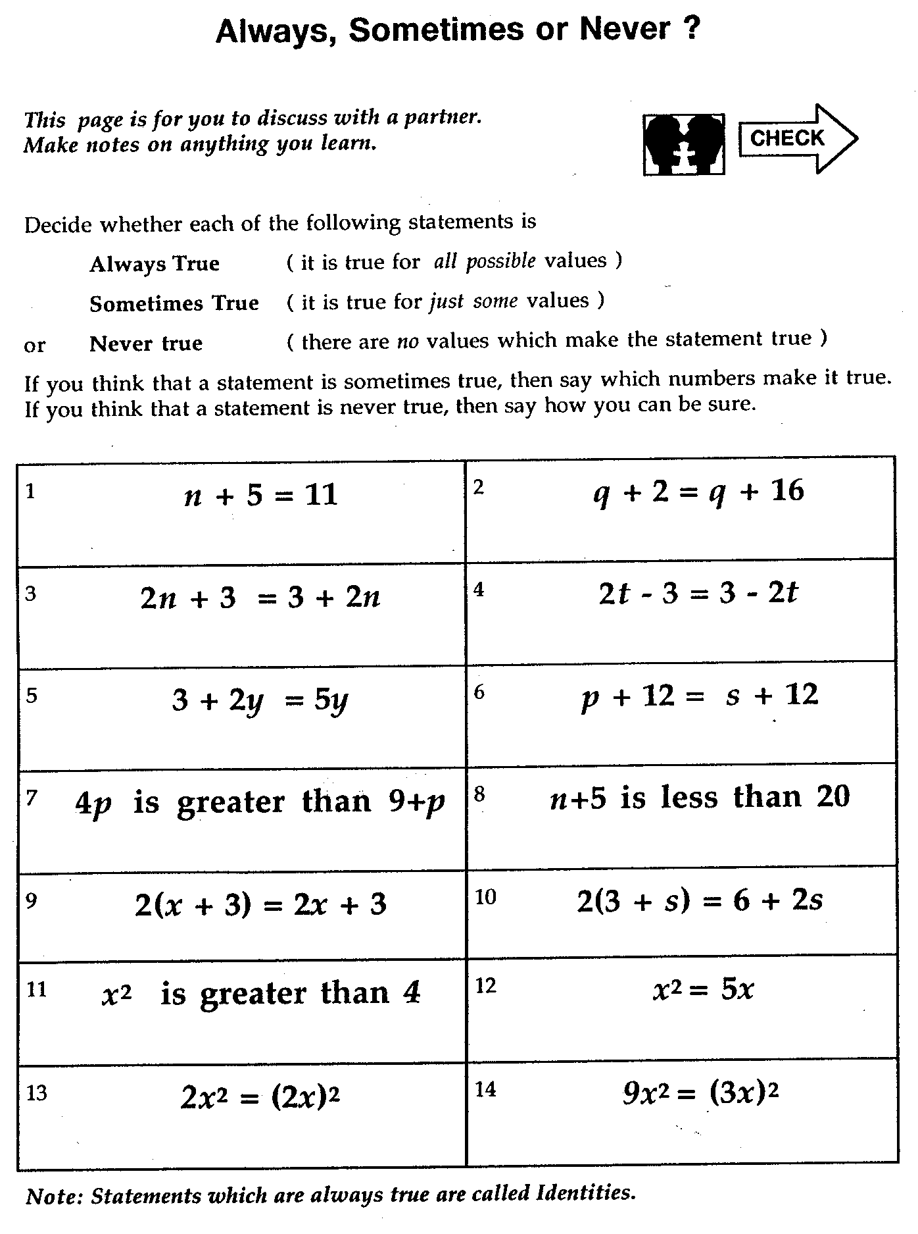

Backward Sums

Write down a 2-digit number.
Write it down with the digits reversed.
Add the two numbers together.

Explain
why the sum is always divisible by 11?
Minimal Skills

Know how to:
• substitute in formulas:
proportional, linear, reciprocal, exponential, quadratic
+ (if calculator) more complex functions

• make tables, plot and interpret graphs of
functions, noting eg max , min, zeros, gradient..

• interpret and sketch graphs of situations
noting eg max , min, zeros, gradient....

• solve f(x)=0, and f(x)=g(x) graphically
solve f(x)>g(x) or f(x)<g(x) graphically

• solve linear equation: 1 eqn, 1 variable

• translate between representations

Use the above in formulating models appropriately with numbers, graphs and functions
Examples

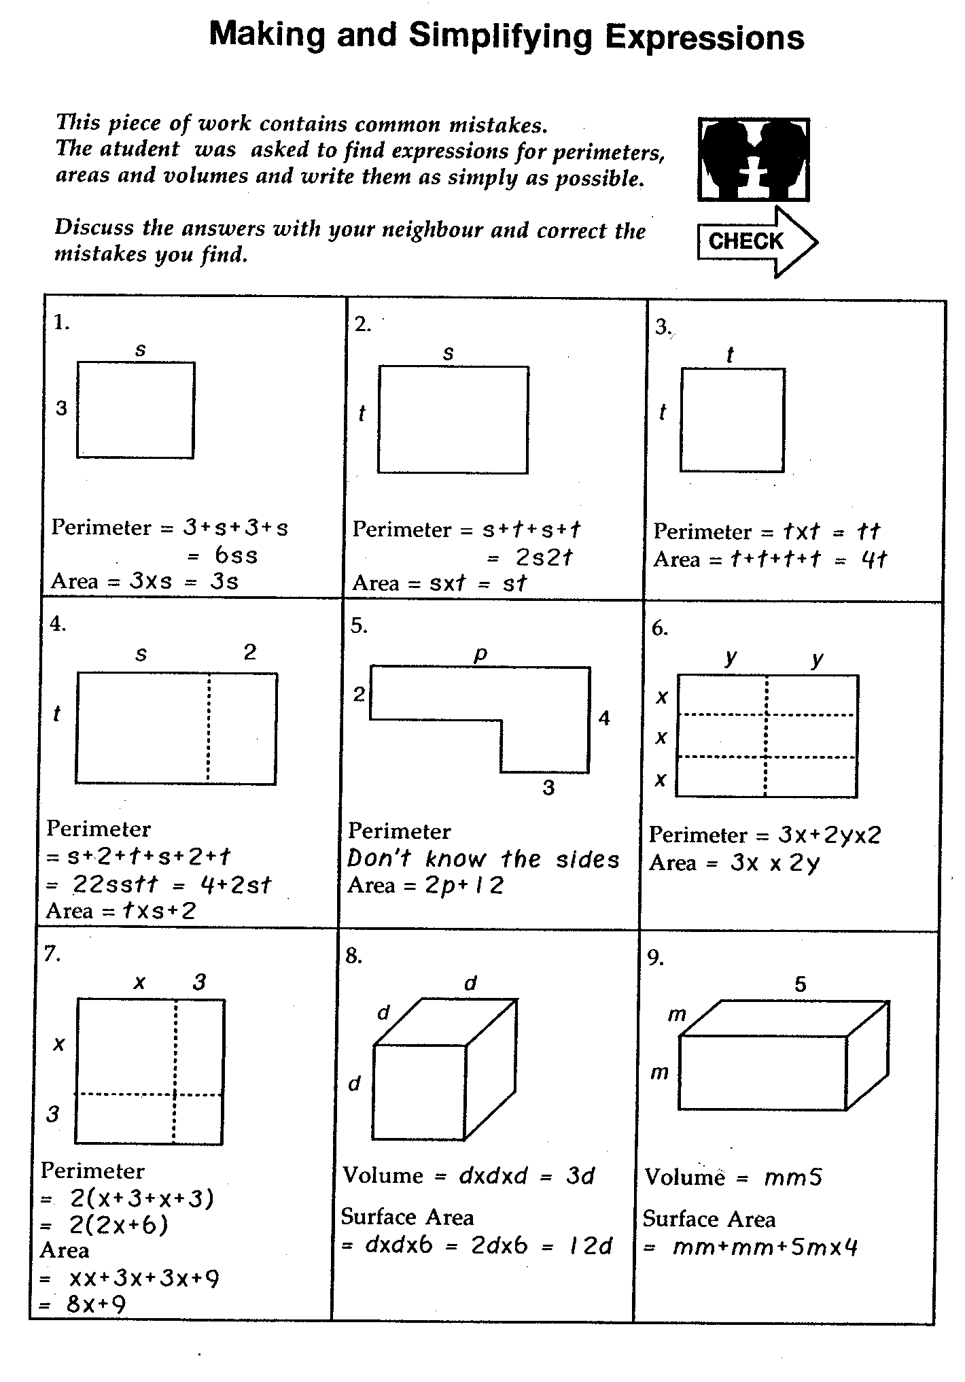

Specialist Growth

In 1998 there were 429,316 people employed in the US as computer support specialists.

Accordingly to the Bureau of Labor Statistics, that number is expected to grow to 868,674 by 2008.

Assuming a constant annual increase in the number of specialists, what will the number be in 2006.

Give the algebraic model for this growth.

Translation Skills

From  To | Situations  Words | Tables | Graphs | Formulae,  symbols
Situations  Words |  | interpret | interpret  graphs | recognizing  formulae
Tables | collect  data |  | read off  points | calculate  values
Graphs | sketch  graphs | plot graphs |  | plot graphs  of functions
Formulae,  symbols | model  situations | ‘ algebraic fit’  or model data | ‘ graph fit’ or  model graph | manipulate

Bold: Traditional school emphasis
Italic: Increased emphasis recently
Task Types

Task Type will be one of:

open investigation

non-routine problem

design or plan

evaluation and recommendation

review and critique

re-presentation of information

definition of concepts

technical exercise

Aspects of understanding, or mathematical power

Imitation

Retention

Explanation

Adaptation

Extension

