Golden Rectangle Investigation (Take measurements from overleaf or the GSP file GoldenRectangleRITEMATHS, not from this page)

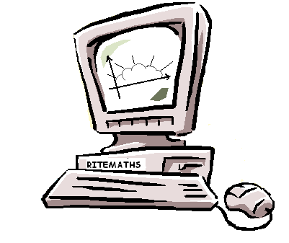
Rect-angle No. | Exact Calculations |  |  |  | Measurements (approximate)
Rect-angle No. | Longer side | Shorter  side | Area | Longer:  shorter  ratio | Longer side | Shorter side | Area | Longer:  shorter  ratio
1  (first large size) |  |  |  |  | 7.24 cm | 4.47cm
2
(yellow)

3
(blue)

4
(purple)

5
(green)

6
(keep going)

7

Diagram for measurement

