The Danish flag
Question 1 – The princess’ birthday

The Danish flag has a white cross over a red background. Both stripes of the white cross always have the same width.

For the official celebration of Princess Alexandra’s birthday on June 30th, the royal family ordered a special flag that should obey the following requirements:

The flag should measure 3m by 2m.

The area of the white cross is equal to the area of the red surface.

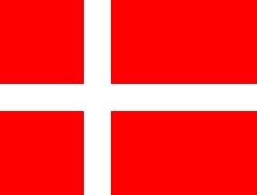
How wide should the stripes be to meet the above requirements? This page helps you solve this problem. You can check your work using the GSP file.
2m
?
?
3 m

1. Does the total area of white on the flag vary according to the distance of the white cross from the edge of the flag?

……………………..

2. Let x be the width of the stripes.
(i) What is the total area of the white cross in terms of x? (Be careful!)

……………………..
(ii) What is the total area of the flag?

……………………..
(iii) What is the area of the red portion of the flag?

……………………..
(iv) Write an equation that says the area of red is equal to the area of white and solve it to find the value of x.

……………………..

……………………..

(v) Repeat the steps above to find the width of the stripes if the area of red is twice the area of white.

Question 2 – The official flag
- In the previous question, what was the ratio of the area of the red surface to the area of the cross?

……………………..

- The dimensions of the national Danish flag as originally specified in 1748 are such that the ratio of the area of the cross to the remaining area is 32:10. Knowing that an official flag is 14m x 18m, find out the width of the cross of an official flag.

