Name _ _ _ _ _ _ _ _ _ _ _ _ __ _ _ _ Teacher _ _ _ _ _ _ _ _ _ Date _ _ _ _ _ _

PLEASE WRITE DOWN ALL OF YOUR WORKING.
IF YOU USE YOUR GRAPHICS CALCULATOR, WRITE “GC” BESIDES YOUR ANSWER

Question 1. To hire a plumber, you have to pay
      - a fixed amount PLUS
      - a cost depending on how long it takes to have the work done.
Bob and Chris are two plumbers. This graph shows the cost of hiring each of them.

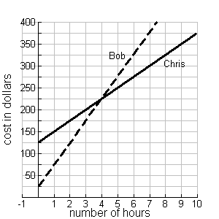

- If you have $325, how long can you hire Bob for? ……………..…………………..
- Is it cheaper to hire Bob or Chris? Explain your answer.

- Explain in words how to work out the cost of hiring Bob if you knew he would be working for 14 hours, WITHOUT EXTENDING THE GRAPH.

- Explain in words how to work out the cost of hiring Bob if you knew the number of hours he would be working, WITHOUT EXTENDING THE GRAPH.

- Use algebra to write a rule to work out the cost in dollars with the number of hours of hiring Bob.
……………..…………………..

- At Christmas, Bob gives all his customers a $10 discount but Chris gives all his customers a discount of $5 for every hour that he works. Add new graphs on the axes below to show the new hiring costs for Bob and Chris.
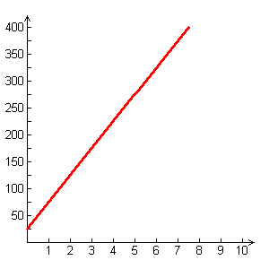
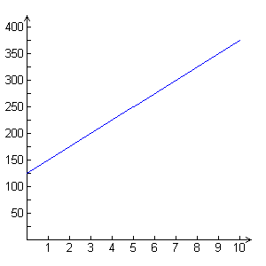
Cost in dollars
Cost in dollars
Chris’s usual charge

Bob’s usual charge

Number
of hours
Number
of hours

Chris
Bob

g) After Christmas, in order to attract more business, Bob also decides to change cost of hiring, by changing his daily charge after 5 hours. The graph below shows his new plan.
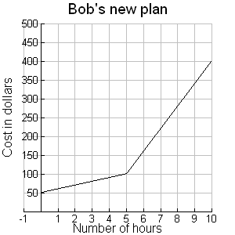 | - Describe, in words, his new plan.  ................................................................................................  ................................................................................................  ................................................................................................  ................................................................................................  ................................................................................................  ................................................................................................  - If a person paid Bob for 6 hours work, but Bob had to come back the next day and work a further 8 hours, how much more would they have to pay?  ……………..…………………..
- Sketch a graph of the hourly charge for Bob’s new plan.
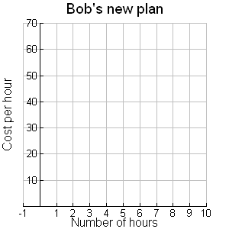

Question 2. At a fun park there are two ways of paying.
CHEAP RIDES TICKET: You pay $32 to get in and then pay $2 per ride

CHEAP ENTRY TICKET: You pay $10 for to get in and then pay $3 per ride
- Jonathan bought the cheap rides ticket. He paid $32 to get in and then paid $2 per ride. Altogether he spent $92. How many rides did he have?

- Did Jonathan choose the best option? Explain your answer.

- Use algebra to write a rule connecting the cost of going to the park and the number of rides that you have for:
  - The cheap rides ticket ……………..…………………..
  - The cheap entry ticket ……………..…………………..

- Samantha and Alison went to the park together. Samantha bought the cheap rides and Alison bought the cheap entry. They had the same number of rides and at the end of the visit, they found that they had spent the same amount of money. How many rides did they have? Please show all of your working.

- The manager of the park has been told to increase takings. At the finance meetings he presents the following new entry plans:
P(x) = 20 + 5x
Q(x) =3x + 30

What do you think the x in these rules stands for? ……………..…………………..

Fill in the spaces for the new entry plans on the signs below.
CHEAP RIDES TICKET CHEAP ENTRY TICKET
Entry $.... .. Entry $ …….
and $ ….. per ride and $ .…… per ride

Question 3.
a) The Smith family went on a long car trip during the school holidays. The graph below represents their journey. The vertical axis shows the distance (in kilometres) away from home and the horizontal axis shows the time (in days) since the start of their trip..

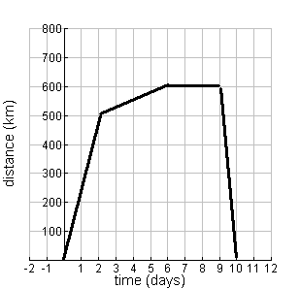 | (i) During which days did the Smith family travel fastest? How can you tell? ………………………………………  ………………………………………  ………………………………………  (ii) They stayed with friends for a few days. Which days were these?  ………………………………………  (iii) How long did it take them to get home from their destination?  ………………………………………  (iv) On average, how fast (measured in kilometres per day) did the Smith family travel to get to their destination?  ………………………………………

b) If part of another trip could be represented by this table.  - How fast were the Smiths travelling? …………………………………………  - Write an algebraic expression which could be used to work out how far (k) Jo walked in d days.  …………………………………………………
  Time (days) | Distance (km)
  0 | 0
  1 | 150
  2 | 300
  3 | 450
  8 | 1200

Question 4.

- If 2n +32 =92, what is the value of n ?

- If 32 +2n =10 +3n, what is the value of n ?

- We know that x and y are numbers and we know that y = 11 + (7x + 4) and that 7x + 4 = 5. What number does y stand for?

