Name _ _ _ _ _ _ _ _ _ _ _ _ __ _ _ _ Teacher _ _ _ _ _ _ _ _ _ Date _ _ _ _ _

PLEASE WRITE DOWN ALL OF YOUR WORKING
Question 1. To hire a truck, you have to pay
      - a fixed amount PLUS
      - a cost depending on how long you keep the truck.
This graph shows the cost of hiring Jill’s truck and the cost of hiring Jack’s truck.
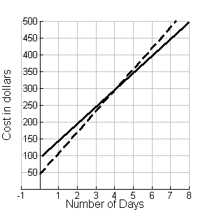
Jill’s truck
Jack’s truck

- If you have $400, for how many days can you hire Jill’s truck? …………………..
- What is the extra cost to hire Jill’s truck for one extra day? …………………..
- What is the fixed amount at the beginning of the hire of Jill’s truck? …………………..
- For what number of days rental is it more costly to hire Jill’s truck than Jack’s? ……………
- Explain in words how to work out the cost of hiring Jill’s truck for 14 days WITHOUT USING THE GRAPH.
……………………………………………………………………………………………………….
……………………………………………………………………………………………………….
……………………………………………………………………………………………………….
……………………………………………………………………………………………………….
- Use algebra to write a rule connecting the cost in dollars with the number of days of hire of Jill’s truck. ……………………………………………………………………………………..

- In order to attract more business, Jill decides to keep the same fixed charge but charge only $40 for each day. On the graph below, draw the graph of the new cost of hiring her truck.

Jill’s truck
Jack’s truck

- Jack also decides to change his hiring plan, by changing his daily charge after 5 days. The graph below shows his new plan.
- Describe, in words, his new plan.
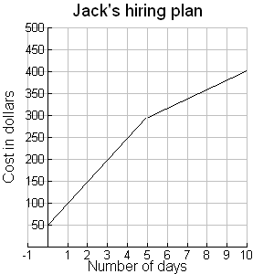 | ................................................................................................  ................................................................................................  ................................................................................................  ................................................................................................  ................................................................................................  ................................................................................................  ................................................................................................
- If person paid for 14 days but kept the truck for 16 days, how much more would they have to pay?

- Sketch a graph of the daily charge for Jack’s new plan.
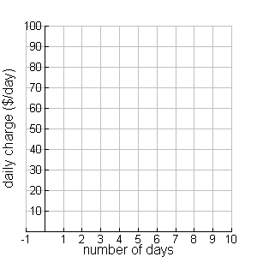

Question 2. The MIRACLE vacuum cleaner costs $136 and you must also buy disposable dust bags which cost $3 each. The WIZARD vacuum cleaner costs only $110 but the disposable dust bags in this case cost $4 each.
- How much would you pay for a MIRACLE vacuum cleaner and 4 dust bags? ………………
- A shop sells the MIRACLE vacuum cleaner and some dust bags for a total of $196. How many dust bags would you expect to get? …………………..
- Explain why: …………………..…………………..…………………..…………………..
- Mary bought a MIRACLE vacuum cleaner and some dust bags.
William bought a WIZARD vacuum cleaner and some dust bags.
By chance, Mary paid the same amount of money as William and she got the same number of dust bags.
  - How many dust bags did they each get? …………………..

  - How much money did they each spend? …………………..

- If you were buying a new vacuum cleaner which of these two options would you choose? Explain your answer.
…………………..…………………..…………………..…………………..…………………..
…………………..…………………..…………………..…………………..…………………..
- Use algebra to write a rule that shows how to work out the cost in dollars of a WIZARD vacuum cleaner from the number of dust bags that you buy with it …………………..
- $y = 7x + \text{145}$If the total cost of the another brand of vacuum cleaner with x dust bags could be represented by

What would it cost for 3 additional dust bags? …………………..…………………..
Question 3.
a) The graph below represents Chris’ walk to school. The vertical axis shows the distance (in metres) from home and the horizontal axis shows time (in minutes) since leaving home.

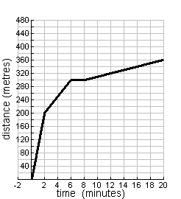 | (i) From the following list, select the description which best describes how fast Chris walked in each time interval.  Stopped, very slowly, slowly, medium, fast, very fast  (ii) How fast did Chris walk (measured in metres per minute) over the whole journey? …..………………………
  Interval | Description
  0 up to 2 minutes
  2 up to 6 minutes
  6 up to 8 minutes
  8 up to 20 minutes

b) Jo’s walk to school can be represented by this table.  - How fast was Jo walking? …………………………………………  - Write an algebraic expression which could be used to work out how far (d) Jo walked in m minutes.  …………………………………………………
  Time (minutes) | Distance (metres)
  0 | 0
  1 | 50
  2 | 100
  3 | 150
  8 | 400
Question 4.
- Find the value of the expression 4b - 3 when b = 6. …………………..
- Is p = 4 a solution to the equation 3p + 1 = p + 5 ? YES / NO Why?
…………………..…………………..…………………..…………………..…………………..
- Is p = 2 a solution to the equation 3p + 1 = p + 5 ? YES / NO Why?
…………………..…………………..…………………..…………………..…………………..
- If 3n +136 =196, what is the value of n ? …………………..

- If 136 +3n =110 +4n, what is the value of n ? …………………..

- We know that x and y are numbers, and we know that y = 11 + (5x + 4) and that 5x + 4 = 3.
What number does y stand for? …………………..

