Year 9 Application Task: Barbie Bungee

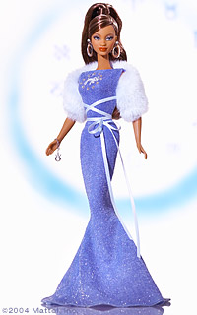
Name: ………………………………………………………

Barbie wants to go Bungee Jumping. She decides to plunge from the mezzanine floor of the new building. You, as the proprietor of the Really Dangerous Adventure Company, will set up the Bungee Jump for Barbie to use.

Part A: Finding the length of the bungee cord
You need to find the length of the bungee cord that Barbie will need to make a successful jump. The cord is to be made from rubber bands.

Materials required: Tape measure, rubber bands, Barbie doll

You are to work in a group of 3 students to perform the following tasks:

- Measure the distance that Barbie falls using a bungee cord of these lengths:

Cord length |  | Distance
 | Trial 1 | Trial 2 | Trial 3 | Average
3 rubber bands
4 rubber bands
5 rubber bands
6 rubber bands
7 rubber bands

- Plot your results on the axes below. Fit a line of best fit to the points.

- On average, how much further does Barbie fall with each rubber band?

________________________________________________________________________________

4. Using your results, find a rule for predicting how far Barbie will fall for a given number of rubber bands. Clearly describe your rule and how it works.

________________________________________________________________________________

________________________________________________________________________________

________________________________________________________________________________

________________________________________________________________________________

________________________________________________________________________________

________________________________________________________________________________

________________________________________________________________________________

________________________________________________________________________________

5. How many rubber bands should it take for Barbie to bungee jump off the mezzanine floor of the new building so that she will stop 10 cm above ground level? Explain how you made your prediction, showing all calculations.

________________________________________________________________________________

________________________________________________________________________________

________________________________________________________________________________

________________________________________________________________________________

________________________________________________________________________________

________________________________________________________________________________

________________________________________________________________________________

________________________________________________________________________________

________________________________________________________________________________

6. Now watch Barbie make the jump. Did your prediction work? How accurate was it?

________________________________________________________________________________

________________________________________________________________________________

Part B: Modelling using a spreadsheet
A spreadsheet is a useful tool for helping us set up mathematical models so that we can make predictions. Use an Excel spreadsheet to plot your data and fit an equation to it.
To do this:
- Open Excel. Enter the number of rubber bands in column A, and the length in column B.

- Graph these results using: Chart Wizard – XY scatterplot.

- Use Excel to produce a line of best fit:
  - Chart menu: Add Trendline
  - Type: Linear, Options: Display equation on chart
  - Make sure that your axes are appropriately labelled

- Save and print your chart.

- Using this information, predict the number of rubber bands needed for Barbie to make a safe jump from the mezzanine floor. Show all your working.

________________________________________________________________________________

________________________________________________________________________________

________________________________________________________________________________

________________________________________________________________________________

________________________________________________________________________________

________________________________________________________________________________

________________________________________________________________________________

6. You now have two different equations for the line of best fit, and two predictions for the number of rubber bands. Discuss and compare the two predictions. How close are they? Which is the more accurate and why?

________________________________________________________________________________

________________________________________________________________________________

________________________________________________________________________________

________________________________________________________________________________

________________________________________________________________________________

________________________________________________________________________________

________________________________________________________________________________

________________________________________________________________________________

Part C: Modelling using a TI-83 or TI-84
Your Graphics Calculator is also a useful tool for helping you set up mathematical models so that you can make predictions. Use your calculator to plot your data and fit an equation to it.

To do this:
- Press the STAT button, 1:Edit, Enter
Enter the number of rubber bands in L1, and the length in L2.
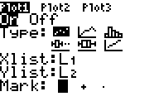
- Graph these results using: STAT PLOT
Remember to set the WINDOW so that all
plotted points can be seen.

- To find the equation for the line of best fit and to graph this line of best fit:
  - Press: STAT , CALC , 4: LinReg(ax+b)
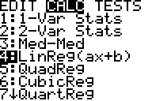

  - Then type: L₁ , L₂ , VARS , Y-VARS , 1: Function , 1: Y₁ , ENTER

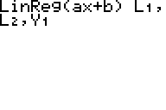

  - The equation of the line of best fit will now be displayed.
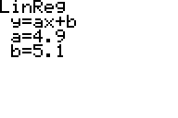

  - Press GRAPH and the line of best fit will be drawn through the plotted points.
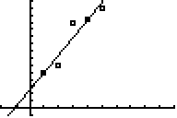

- Write down the equation of the line of best fit found using your calculator.

________________________________________________________________________________

5. How does the equation for the line of best fit found using your calculator compare with the equation found using Excel? Discuss any similarities or differences.

________________________________________________________________________________

________________________________________________________________________________

________________________________________________________________________________

________________________________________________________________________________

________________________________________________________________________________

________________________________________________________________________________

________________________________________________________________________________

