Name _ _ _ _ _ _ _ _ _ _ _ _ __ _ _ _ Teacher _ _ _ _ _ _ _ _ _ Date _ _ _ _ _
PLEASE WRITE DOWN ALL OF YOUR WORKING

Question 1
(a) Write the following in index notation
(i) 5 × 5 × 5 × 5 = (ii) 3 × 5 × 5 × 5 =
(iii) a × a × a = (iv) 5 × c × c × c × c =

(b) Write the following in expanded form
(i) 7⁴ = (ii) c⁶ = (iii) 4a³ =
Question 2
Botswana is a beautiful country in Africa. A large part of the country has been reserved as a wilderness area. This table shows the numbers of some of the grazing animals in the Botswana reserve.
Animal | 1982 | 1986 | 1990 | 1994 | 1998
Wilderbeest | 200 000 | 195 000 | 190 000 | 185 000 | 180 000
Hartebeest | 190 000 | 175 000 | 161 000 | 148 000 | 136 000
Eland | 160 000 | 130 000 | 100 000 | 70 000 | 40 000
Zebra | 66 000 | 56 000 | 46 000 | 36 000 | 26 000
(a) Describe in words how the population change for Hartebeest differs from that for the other animals.
……………………………………………………………………………………………………
……………………………………………………………………………………………………
……………………………………………………………………………………………………
……………………………………………………………………………………………………
(b) Wildlife officers estimate Hartebeest numbers will decrease by 8% every year after 1998. How many Hartebeest do they think there will be in:-
(i) 1999  ……………………….. | (ii) 2001  ………………………..
(c) Wildlife officers believe that Hartebeest numbers in future years can be approximated by the formula, $H = \text{190} \text{000} × (0\text{.}\text{92})^{n}$ where H is the number of Hartebeest and n is the number of years after 1998. Use the formula to estimate the Hartebeest population in the year 2008

Question 3
Property values in a suburb in Sydney are increasing rapidly.
You are in the real estate business in this particular suburb. You wish to plan for future prices in order to advise your clients. You have the following information about house prices in graphical form. The vertical axis shows the price in thousands of dollars and the horizontal axis shows the years.
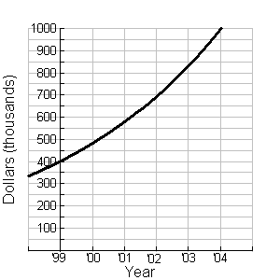
- Approximately, what was the change in average house price from 1999 to 2002? …………………………...
- On average, how much per year was this? …………………………...
- Approximately, what was the change in average house price from 2002 to 2004? …………………………...
- On average, how much per year was this? …………………………...
- Would the information above assist you to advise a client wanting an estimate of prices in 2006. Give a reason for your answer. …………………………...
…………………………………………………………………………………………………
…………………………………………………………………………………………………
…………………………………………………………………………………………………
…………………………………………………………………………………………………

- The graph above shows that the average house price increasing by 20% each year, estimate the average house price in 2006.

…………………………...

- The average price of commercial properties is shown on the graph below.
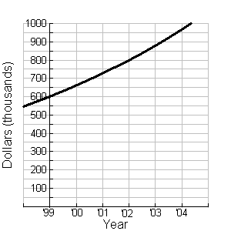
In what ways is the change in commercial property prices different from the house prices?
…………………………………………………………………………………………………
…………………………………………………………………………………………………
…………………………………………………………………………………………………
How can you tell?
…………………………………………………………………………………………………
…………………………………………………………………………………………………
…………………………………………………………………………………………………
Question 4
Your parents want to give you $50 each week for pocket money. Even though that is a lot of money, you come up with a better plan. On June 1, your parents will give you one cent ($0.01). Every day, you will be given double the amount from the day before. Your parents agree, and give you one cent to start.
Fill out the table below to explore what happens to your daily allowance. Show how you worked out each of the values.
Date
June 1
June 2
June 3
June 4
June 5
Write down a formula which could be used to work out how much money will you receive on June 30. …………………………………..
Explain how you worked out the formula.
…………………………………………………………………………………………………
…………………………………………………………………………………………………
…………………………………………………………………………………………………
…………………………………………………………………………………………………

