Exploring Exponential Relationships

Paper Tearing (Graphic Algebra, pages 43-44)

- Complete the following to use CAS to define the paper tearing function and view its graph
  - Go to Home Screen and start new problem
- Select New Prob from Tools menu  Key 2nd F1 2 Enter | 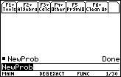
  - Define S(n) = 2^n
- Select Define from Other menu  Key F4 1  Define s(n) = 2^n  Key alpha S ( alpha N ) = 2^alpha N Enter | 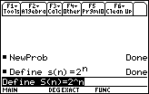
  - Find the value of S(n) for when n= 5
- s(5)  Key alpha S ( 5 ) Enter | 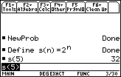
  - Find the values of S(n) when n= 8,9,10
- s(n) | n = {8, 9, 10}  Key alpha S ( alpha N ) | alpha N = { 8 , 9 , 10 } Enter | 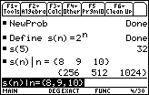
  - Draw the graph of S(n)
Select y1 =  Key green-diamond Y= and move cursor to y1 = | 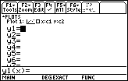
- Set y1 = s(n) | n = x  Key S ( alpha N ) | alpha N = x Enter | 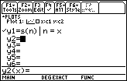
- Select WINDOW  Key green-diamond WINDOW  - Set WINDOW so that:  xmin = -4 xmax = 5 xscl = 1  ymin = -5 ymax = 15 yscal = 2  xres = 2 | 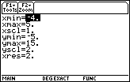
- Draw graph of y1  Key green-diamond GRAPH | 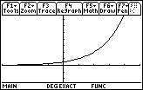
  - Find the value of S(x) when x= 3 on the graph
- Select Value from Math Menu  Key F5 1 Enter | 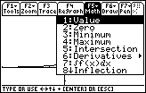
- Set x = 3 to get point (3, s(3)) on the graph showing x = 3 and s(3) = 8  Key 3 Enter | 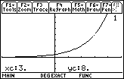

- Find the value of S(n) when n = 10 in the home screen and then confirm this on the graph of y1 = S(n) | n = x. You will need to adjust the graph WINDOW.

- In the home screen, calculate S(n) for different values of n that you choose and, in this way, find (by guess and check) the value of n such that:
- S(n) = 8 192
- S(n) = 524 288
- S(n) = 4 194 304
- S(n) = 4 398 046 511 104

- Find n such that S(n) = 34 359 738 368 using the Solve feature of CAS.

- Select solve from the Algebra menu to get solve( in entry line  Key F2 1  - Complete entry line to read solve(s(n) = 8192, n) and then execute  Key alpha S ( alpha N )= 34359738368 , n ) and then Enter | 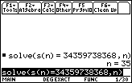

- Use the Solve feature of CAS to confirm your answers to question (3) above.

