Exploring Exponential Relationships

Ozone Layer (Graphic Algebra, pages 45-46)
Set the Mode of your CAS calculator to APPROXIMATE.
- Select MODE menu  Key MODE | 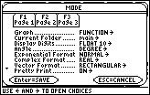
- Select Page 2  Key F2 | 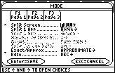
- Scroll down to Exact/Approx, press right arrow to see drop down menu  - Select APPROXIMATE  Key 3 ENTER ENTER | 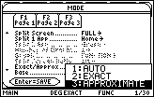

- In the Home Screen, use Define from the Other menu (key F4) to define the function that gives the thickness of the ozone layer.
W(t) = 50(0.99)^t  t is the time elapsed since the start of 1995 | 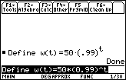
In the Home Screen, use W(t) notation to find the thickness of the ozone layer:
  - when the time elapsed since 1995 is 22.75 years
  - at the start of the year 2010
  - three-eighths of the way through the year 2040
  - when t = 24, 2.658, 20.5, 42.82, 35.7, 0.65 years
(Do all of these at the same time by using a one line entry.)
See Question 1 in the Paper Tearing section if you need help.

- Draw the graph of y = W(x) by setting: y1 = W(t) | t = x
From the graph of y = W(x), find the thickness of the ozone layer:
  - when the time elapsed since 1995 is 75 years
  - when the time elapsed since 1995 is 56.4 years
  - at the start of the year 2075
  - when x = 7.85 years
You may need to adjust the WINDOW for a good view of the graph.
See Question 1 in the Paper Tearing section if you need help.
- Use Solve from the Algebra menu (key F2) and the defined function W(t) to find the time t when the thickness of the ozone layer is:
  - four-fifths of its thickness in the year 1995
  - two-thirds of its thickness in the year 2005
  - 30% of its thickness in the year 2000
  - 200 metres
  - 5 metres
- Using Define from the Other menu, Define the percentage change function, pc(a,b),
pc(a,b) = 100(W(b) – W(a))/W(a) | 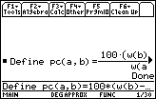
pc(a,b) gives the percentage change in W(t), the thickness of the ozone layer, when the elapsed time since 1995 changes from a years to b years.
  - Use pc(a,b) to find the percentage change in the thickness of the ozone layer from the year 2000 to the year 2008.
  - Use your answer to part (a) to find the percentage of the ozone layer thickness that was present in 2000 that still remains in 2008.
  - Use pc(a,b) to find the percentage change in W(t) when t changes from 2 years to 18 years.
  - Use pc(a,b) to find the percentage change in W(t) when t changes from 23 years to 39 years.
  - What do you notice about your answers to part (c) and part (d)? If t changes from 40 years to 56 years do you get the same result?
  - Choose and confirm a different pair of numbers, (a,b), for use in pc(a,b) that would give the same result as you found in part (e).
  - Type pc(x, x + 16) into the entry line of the Home Screen and press ENTER. What do you notice? Explain what this result tells us about the percentage change in W(t) over a period of years.
  - Now type pc(x, x + k) | k = 16 into the entry line of the Home Screen and press ENTER. What do you notice?
  - Typing pc(x, x + k) | k = 25 into the entry line of the Home Screen and then pressing ENTER gives a number. This number tells us the percentage change in W(t) over what period of years? Does it matter when this period of years begins? To show that your answer is correct write down what you would type into the entry line of the Home Screen, and then press ENTER?
  - Use what you learned from parts (g) to (i) to find the percentage change in the thickness of the ozone layer when the time change is any period of:
    - 28 years
    - 65 years

- The rule that gives the percentage change in the thickness of the ozone layer from what is was in 1995 to t years later can by found by typing pc(0,t) in the entry line of the Home Screen and pressing ENTER.
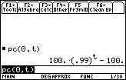
- Enter pc(0,t) = -25 in the Home Screen to find the equation that needs to be solved for t to find the time when the thickness of the ozone layer is 75% of what it was in 1995. | 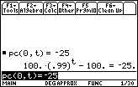
- Add 100 to both sides of this equation. | 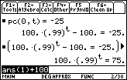
- Divide both sides of the resulting equation by 100. | 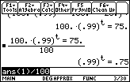
This shows that the time needed for the ozone layer to be 75% of what it was in 1995 is the number t that makes (.99)^t equal to 0.75.
  - Use (.99)^t | t = {10, 20, 30} to find whether this number t lies between 10 and 20 years or 20 and 30 years.
  - Based on the result in (a) choose three suitable numbers to use in (.99)^t | t = {…., …., …. } to get a closer approximation of t by finding which of the two chosen numbers t is between.
  - Based on the result of (b) again choose three suitable numbers and repeat what was done to find an even closer approximation of t.
d. Use Solve from the Algebra menu (key F2) to find the time t needed for the ozone layer to be 75% of what it was in 1995. | 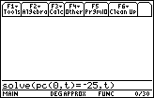
- Use Solve from the Algebra menu to find the time needed for the
thickness of the ozone layer to be:
    - 80% of what it was in 1995
    - 30% of what it was in 1995
    - 65% of what it was in 2004 Hint: Use pc(9,t)
    - 10% of what it was in 2000

